Motjoka Fanana ST10089515 SAND6221 TAKE HOME TEST

**QUESTION 1**

According to Alexander S. Gillis (2019)

1) Requirement Gathering:

Talk to canteen managers, staff, and students to understand what they want from the app.

Write down what they need, such as ordering food, scheduling deliveries, and paying by credit card.

Determine what is most important and feasible for the application.

2) System analysis:

Review the requirements and understand exactly what the campus canteen app needs to do.

Find out what problems or risks can arise when creating apps. Create scenarios to see how students will use the app and decide what features the app needs.

3) System design:

Create a design that students will find easy to use and love.

Draw an image or sketch of the app's interface to get user feedback.

Plan how the app will securely store orders, student information, and manage payments.

Decide on the technology and elements needed to make the app work.

4) Development:

Create a part of the application that students see and interact with using web or mobile technology.

Write code that allows the app to process orders, schedule deliveries, and manage payments.

Connect the app to a safe and secure credit card payment system.

Continue testing the app during the build process to troubleshoot and make sure it's working properly.

5)Deployment:

Configure the server and prepare the application for actual use. Place the application on a hosted platform that is accessible to students.

Double-check everything to make sure the app works in a real environment.

Create simple tutorials and guides to help users install and use the app.

6) Operation and maintenance:

Monitor the performance of the application if the application is still available and safe.

Help canteen staff and students if they have any questions or problems with the app. Update the app regularly, fix bugs and improve the app based on user feedback.

7)System improvements:

Listen to what people are saying about the app and find ways to make it even better.

Decide which changes or new features are most important and implement them first.

Test changes to make sure they integrate well with the app and don't cause new problems. (TechTarget,2019).

**Question 2**

Q.2.1)

Order Placement:

* The application should allow students to browse the menu, select food, and adjust their order as needed.
* Facilities should be provided for canteen staff to specify portions, dietary preferences, and additional instructions.

Delivery Schedule:

* The application should provide the ability for students to schedule delivery of orders to specific locations on campus.
* Users should be able to select their preferred delivery time slot to ensure flexibility and accommodate availability.

Processing credit card payments:

* Your application should support secure credit card payments and allow students to complete transactions online.
* To securely process payments and provide your users with a seamless checkout experience, you need to integrate with a reliable and secure payment gateway.

Q.2.2)

Students

Canteen Staff

Canteen Management

Q.2.3)

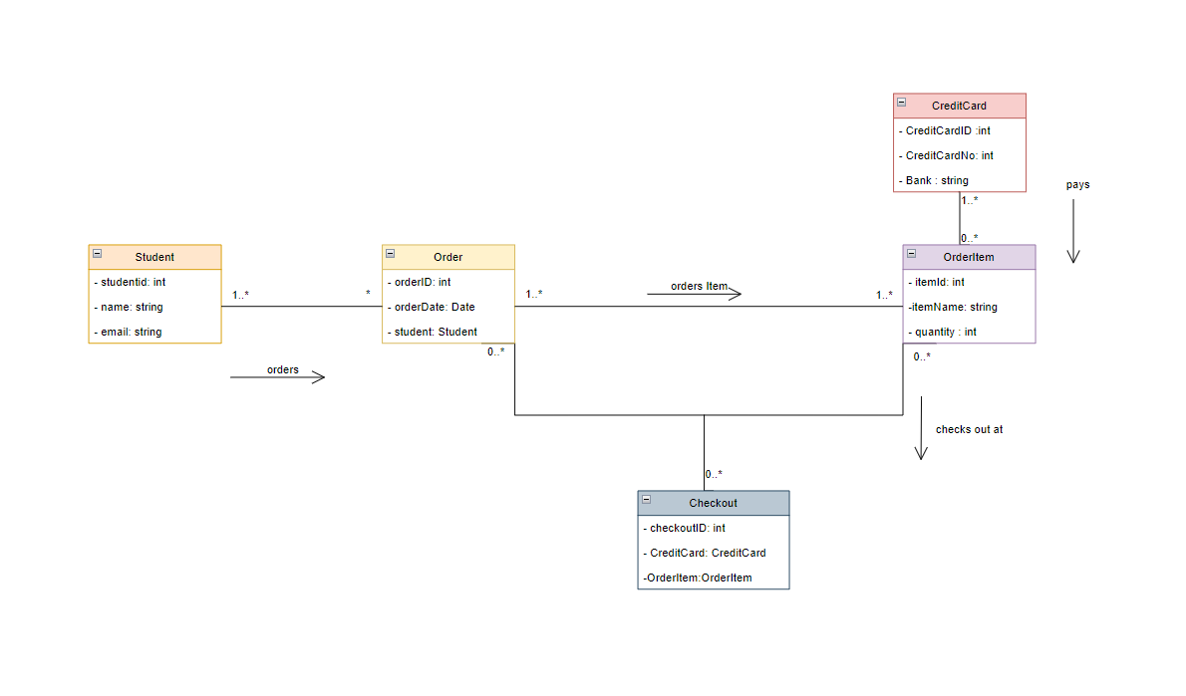

Q.2.4)

Use Case Name: ORDER PLACEMENT

Brief Description:

This use case describes the ordering process in a campus cafeteria application. This allows students to select groceries, customize orders, and give additional instructions to cafeteria staff.

Actor(s):

 Student: The primary actor that interacts with your application to place an order.

Flow of Activity:

* 1 Students launch the Campus Canteen application on their device.
* 2 The application will display the available menu options.
* 3 The student scrolls through the menu and selects the desired food item.
* 4 For each item selected, students indicate their preference for quantity and personalization. B. Toppings or Spices.
* 5 Students review the order summary and confirm that the selected items and quantities are correct.
* 6 If desired, students can change the order by removing or adding items or adjusting the quantity.
* 7 Students proceed to payment. 8 On the application form, students are asked to provide additional instructions or special requests to canteen staff, such as: B. Dietary restrictions or preferences.
* 9 Students confirm their order and proceed to the payment area.
* 10 The application securely processes payments using the student's preferred credit card payment method.
* 11 Upon successful payment processing, the application will generate an order confirmation containing a unique order number and display this to the student.
* 12 Cafeteria staff receive order data, including items selected, quantities and any special instructions. 13 The cafeteria staff prepares orders for delivery or pick-up according to the student's wishes.
* 14 The application notifies the student of the estimated delivery or pick-up time.
* 15 Students receive their orders and enjoy their meals within the designated time.

**Question 3**

Q.3.1)

SSL (Secure Sockets Layer)/TLS encryption:

* Establish a secure and encrypted communication channel using SSL/TLS encryption.
* Encrypt sensitive data, such as credit card information, during transmission to prevent unauthorized access.

Payment card industry data security standard (PCI DSS) compliance:

* Complies with PCI DSS requirements for secure handling of credit card data.
* Use PCI DSS compliant payment gateways and processors to securely process credit card transactions.

Role-based access control (RBAC):

• Implement RBAC to control and restrict access to different parts of the application based on user roles and responsibilities.

• Assign specific access privileges to canteen staff, administrators, and other authorized users, restricting their access to essential functions and data.

• Regularly review and update user roles and access permissions to ensure they reflect current organizational needs and staffing changes.

Implement strong password policies, including password complexity requirements and frequent expiration of passwords, to improve user authentication and reduce the risk of unauthorized access.

Q.3.2)

User-centric design:

* Talk to canteen staff and students to understand what they want and need from the app.
* Design the application interface so that it is easy to use, with clear menus and buttons, streamlined information, and beautiful appearance. (Harsha, S,2019)

Usability Testing:

* Ask a representative group of users to try the app and provide feedback.
* Use their feedback for improvements, such as adjusting the layout or adding useful features, to ensure the app is user-friendly and meets their needs. (THE INTERACTION DESIGN FOUNDATION,2019)

**REFERENCE**

Gillis, A.S. (2019) *What is systems development life cycle? - definition from whatis.com*, *Software Quality*. Available at: https://www.techtarget.com/searchsoftwarequality/definition/systems-development-life-cycle (Accessed: 19 May 2023).

Harsha, S. (2019) *Usability testing in design - why is it important?* *Medium*. Available at: https://uxdesign.cc/usability-testing-in-design-and-why-is-it-important-cfddfbbdaac9 (Accessed: 19 May 2023).

*What is user centered design?* (2023) *The Interaction Design Foundation*. Available at: https://www.interaction-design.org/literature/topics/user-centered-design (Accessed: 19 May 2023).

Fanana, M. (2023) ‘Diagram.io’, *diagram.io*. Available at: diagram.io (Accessed: 19 May 2023).

*UML use case diagram tutorial* (no date) *Lucidchart*. Available at: https://www.lucidchart.com/pages/uml-use-case-diagram (Accessed: 19 May 2023).

*UML models and diagrams* (2021) *IBM*. Available at: https://www.ibm.com/docs/en/rational-soft-arch/9.6.1?topic=diagrams-uml-models (Accessed: 19 May 2023).

*Entity relationship diagram* (no date) *Entity Relationship Diagram - Data Modeling - UML Diagramming Software*. Available at: https://www.visual-paradigm.com/VPGallery/datamodeling/EntityRelationshipDiagram.html (Accessed: May 19, 2023).

*UML - Basic notations* (no date) *Tutorials Point*. Available at: https://www.tutorialspoint.com/uml/uml_basic_notations.htm (Accessed: May 19, 2023).

Coronel, C. *et al.* (2020) *Database principles: Fundamentals of design, implementation, and management*. Australia: Cengage.